Promoter analysis of the saxitoxin gene cluster identifies bottlenecks in biosynthesis

Paul M. D’Agostino^{1,2,3, a}, Bakir Al-Sinawi^{2, a}, Rabia Mazmouz², Julia Muenchhoff^{2,4}, Brett A. Neilan^{2,5*}, Michelle C. Moffitt ¹*

¹School of Science and Health, Western Sydney University, Sydney, NSW, Australia
²School of Biotechnology and Biomolecular Sciences, University of New South Wales, Sydney, NSW, Australia
³Biosystems Chemistry, Department of Chemistry, Technische Universität München, Garching, Germany
⁴Centre for Healthy Brain Ageing, School of Psychiatry, University of New South Wales, Sydney, Australia
⁵School of Environmental and Life Sciences, University of Newcastle, Callaghan, Australia
ªAuthors contributed equally

SUPPORTING INFORMATION

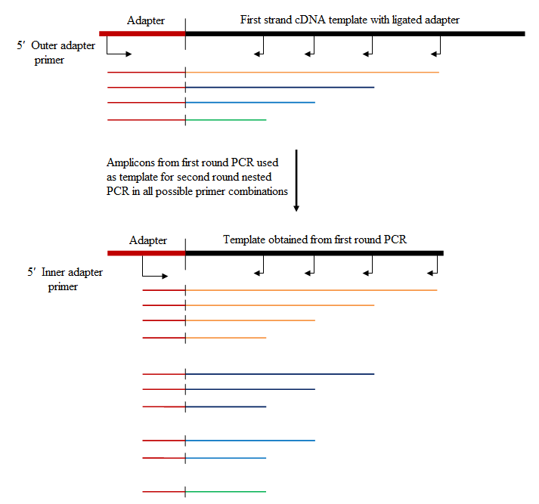

Figure S1: Nested PCR for the determination of TSPs
As a template for 5′ RACE, cDNA was synthesised from RNA containing a small adapter ligated to the 5′ end of mRNA transcripts. First round PCR to determine TSSs of the sxt gene cluster was achieved with a 5′ outer adapter primer in conjunction with 4 reverse facing GSPs Amplicons generated from first round PCR was used as a template for second round PCR. Amplification was performed in combination with all possible reverse facing primers in conjunction with a 5′ inner adapter primer. Knowledge of the distance between primers allowed for distinction between correct bands and background amplification.

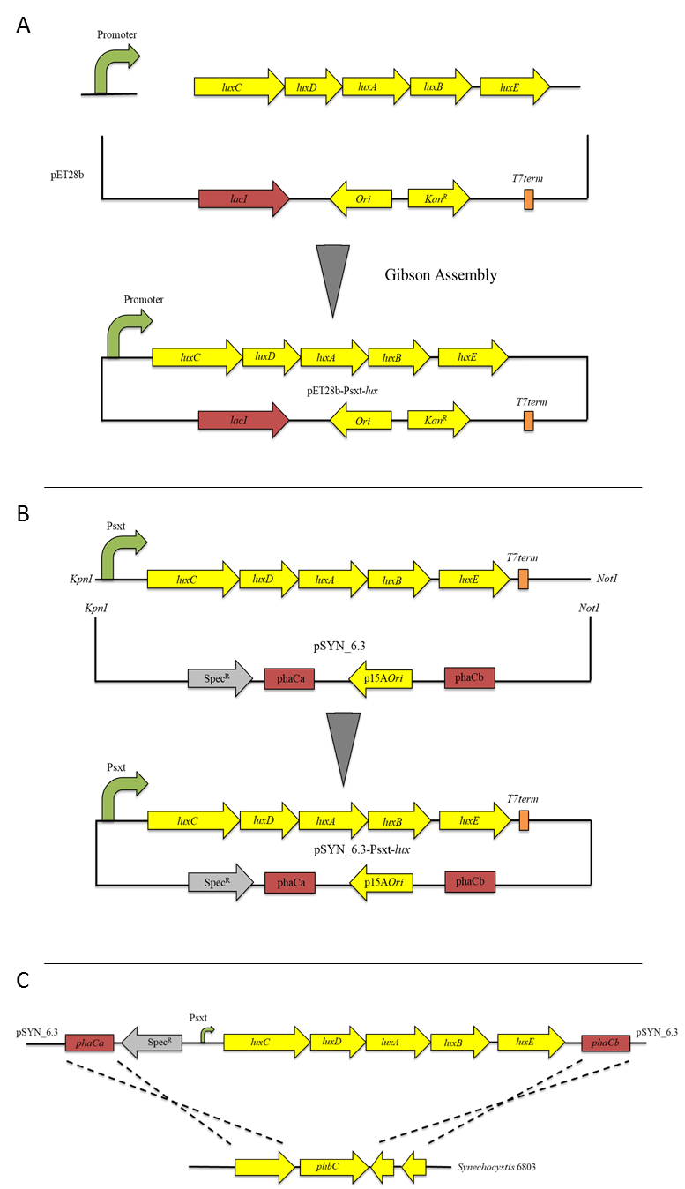
Figure S2. Cloning of Psxt-lux E. coli expression vectors and Synechocystis integration vectors: (A) Linear luxCDABE and promoter fragments were cloned into the pET28b vector through Gibson assembly. (B) P-lux fragments were digested with NotI/KpnI and ligated into the pSYN_6.3 vector. (C) Transformation of Psxt-lux into the Synechocystis PCC6803 genome: The pSYN_6.3 vector was mobilised into Synechocystis PCC6803 through natural transformation. The Psxt-lux fragment on the pSYN_6.3 vector was integrated into the Synechocystis PCC6803 genome by replacing the phbC gene through homologous recombination.

Table S1: Transcript termination sites determined by TranstermHP
Operon | dG | Score | 5′ Tail | Stem-loop | 3′ tail
1 | - | - | - | - | -
2 | -7.7 | -3.95 | TCCTTTTTACAAAAA | TGGGA-TGC-TCCCA | TTTAATTGCGCTTTT
3 | -2.5 | -2.95 | TAAACTACGGCTATT | TGAATAATG-GGAGAG-CATTATCCA | TAATTATTACCTCGT
4 | -4 | -4.58 | CTTA-ACA-TAAG | CTTA-ACA-TAAG | TTTTTCCCACAATTC

Table S2: unpaired t-tests E. coli
Table Analyzed | RLU/OD | RLU/OD | RLU/OD | RLU/OD | RLU/OD | RLU/OD
Column F | PsxtP | Control | Control | Control | Porf24 | Control
vs. | vs. | vs. | vs. | vs. | vs. | vs.
Column E | Control | PsxtPER | PsxtD | PsxtPER2 | Control | PsxtO
Unpaired t test
P value | <0.0001 | <0.0001 | <0.0001 | <0.0001 | <0.0001 | <0.0001
P value summary | **** | **** | **** | **** | **** | ****
Significantly different (P < 0.05)? | Yes | Yes | Yes | Yes | Yes | Yes
One- or two-tailed P value? | Two-tailed | Two-tailed | Two-tailed | Two-tailed | Two-tailed | Two-tailed
t, df | t=9.711 df=13 | t=13.52 df=13 | t=7.296 df=13 | t=10.77 df=13 | t=11.42 df=10 | t=9.649 df=13
How big is the difference?
Mean ± SEM of column E | 1467 ± 136.5, n=9 | 157740426 ± 14574405, n=6 | 926543945 ± 158604243, n=6 | 2600089 ± 301443, n=6 | 1467 ± 136.5, n=9 | 97263 ± 12398, n=6
Mean ± SEM of column F | 111526337 ± 14343689, n=6 | 1467 ± 136.5, n=9 | 1467 ± 136.5, n=9 | 1467 ± 136.5, n=9 | 1188002 ± 201199, n=3 | 1467 ± 136.5, n=9
Difference between means | 111524871 ± 11484142 | -157738959 ± 11668863 | -926542478 ± 126985023 | -2598622 ± 241348 | 1186535 ± 103899 | -95796 ± 9928
95% confidence interval | 86714890 to 136334851 | -182948005 to -132529913 | -1200876941 to -652208015 | -3120022 to -2077222 | 955034 to 1418037 | -117244 to -74348
R squared (eta squared) | 0.8789 | 0.9336 | 0.8037 | 0.8992 | 0.9288 | 0.8775
F test to compare variances
F, DFn, Dfd | 7366117336, 5, 8 | 7604988994, 5, 8 | 900630216132, 5, 8 | 3253323, 5, 8 | 724666, 2, 8 | 5503, 5, 8
P value | <0.0001 | <0.0001 | <0.0001 | <0.0001 | <0.0001 | <0.0001
P value summary | **** | **** | **** | **** | **** | ****
Significantly different (P < 0.05)? | Yes | Yes | Yes | Yes | Yes | Yes

Table S3: Relative expression of promoters vs control in E. coli
pSXL1 | pSXL2 | pSXL3 | pSXL4 | pSXL5 | pSXL6
631591 | 76023 | 107526 | 810 | 1772 | 66

Table S4: P values from one-way ANOVA in E. coli
 | PsxtD | PsxtP | PsxtPER | Porf24 | PsxtPER2 | PsxtO
PsxtD |  | <0.0001 | <0.0001 | <0.0001 | <0.0001 | <0.0001
PsxtP | <0.0001 |  | >0.9999 | >0.9999 | >0.9999 | >0.9999
PsxtPER | <0.0001 | >0.9999 |  | >0.9999 | >0.9999 | >0.9999
Porf24 | <0.0001 | >0.9999 | >0.9999 |  | >0.9999 | >0.9999
PsxtPER2 | <0.0001 | >0.9999 | >0.9999 | >0.9999 |  | >0.9999
PsxtO | <0.0001 | >0.9999 | >0.9999 | >0.9999 | >0.9999

Table S5: Unpaired t-tests Synechocystis
Table Analyzed | RLU/OD | RLU/OD | RLU/OD | RLU/OD
Column E | Control | Control | Control | Control
vs. | vs. | vs. | vs. | vs.
Column B | PsxtP | PsxtPER | Porf24 | PsxtD
Unpaired t test
P value | 0.002 | <0.0001 | 0.0105 | 0.1347
P value summary | ** | **** | * | ns
Significantly different (P < 0.05)? | Yes | Yes | Yes | No
One- or two-tailed P value? | Two-tailed | Two-tailed | Two-tailed | Two-tailed
t, df | t=7.19 df=4 | t=34.09 df=4 | t=4.536 df=4 | t=1.871 df=4
How big is the difference?
Mean ± SEM of column B | 243162 ± 29557, n=3 | 428831 ± 11066, n=3 | 126747 ± 21240, n=3 | 38636 ± 3532, n=3
Mean ± SEM of column E | 28791 ± 3902, n=3 | 28791 ± 3902, n=3 | 28791 ± 3902, n=3 | 28791 ± 3902, n=3
Difference between means | -214372 ± 29814 | -400040 ± 11734 | -97957 ± 21595 | -9846 ± 5263
95% confidence interval | -297148 to -131595 | -432618 to -367462 | -157915 to -37998 | -24458 to 4767
R squared (eta squared) | 0.9282 | 0.9966 | 0.8372 | 0.4666
F test to compare variances
F, DFn, Dfd | 57.39, 2, 2 | 8.044, 2, 2 | 29.64, 2, 2 | 1.22, 2, 2
P value | 0.0343 | 0.2211 | 0.0653 | 0.9008
P value summary | * | ns | ns | ns
Significantly different (P < 0.05)? | Yes | No | No | No

Table S6: Relative expression of promoters vs control in Synechocystis
PsxtD | PsxtP | PsxtPER | Porf24
1.34 | 8.45 | 14.89 | 4.40

Table S7: P values from one-way ANOVA in Synechocystis
 | PsxtD | PsxtP | PsxtPER | Porf24
PsxtD |  | 0.0004 | <0.0001 | 0.069
PsxtP | 0.0004 |  | 0.0008 | 0.0155
PsxtPER | <0.0001 | 0.0008 |  | <0.0001
Porf24 | 0.069 | 0.0155 | <0.0001

Table S8: Strains and plasmids
Organism | Purpose | Ref.
DH5α | Expression host of lux reporter assay | Promega
TOP 10 | Transformation and propagation of plasmids | Invitrogen
D. circinale AWQC131C | Organism harbouring native sxt cluster | (Mihali et al., 2009)
Synechocystis sp. PCC6803 | Expression host of lux reporter assay
E. coli DH5α SXL1 | pET28b- PsxtD-luxCDABE | This study
E. coli DH5α SXL2 | pET28b- PsxtP-luxCDABE | This study
E. coli DH5α SXL3 | pET28b- PsxtPER-luxCDABE | This study
E. coli DH5α SXL4 | pET28b- Porf24-luxCDABE | This study
E. coli DH5α SXL5 | pET28b- PsxtPER2-luxCDABE | This study
E. coli DH5α SXL6 | pET28b- sxtO-luxCDABE | This study
E. coli DH5α-lux | pET28b-luxCDABE | This study
Synechocystis SXL7 | ΔphbC :: PsxtD-luxCDABE - Spec^{R} | This study
Synechocystis SXL8 | ΔphbC :: PsxtP-luxCDABE - Spec^{R} | This study
Synechocystis SXL9 | ΔphbC :: PsxtPER-luxCDABE - Spec^{R} | This study
Synechocystis SXL10 | ΔphbC :: Porf24-luxCDABE - Spec^{R} | This study
Synechocystis SXL11 | ΔphbC :: luxCDABE - Spec^{R} | This study
Plasmids | Purpose | Ref.
pCR™2.1 TOPO | Cloning and sequencing of 5′ RACE TSS products | Invitrogen
pGEM T-Easy | Cloning and sequencing of 5′ RACE TSS products | Promega
pET28b | Cloning and expression of saxitoxin promoters | Novagen
pSYN_6.3 | Cloning and transformation of saxitoxin promoters in Synehcocystis sp. PCC 6803 | Unpublished
pLUX NS II | luxCDABE | (Woelfle et al., 2007)
pSXL1 | pET28b::PsxtD-luxCDABE | This study
pSXL2 | pET28b::PsxtP-luxCDABE | This study
pSXL3 | pET28b::PsxtPER-luxCDABE | This study
pSXL4 | pET28b::Porf24-luxCDABE | This study
pSXL5 | pET28b::PsxtPER2-luxCDABE | This study
pSXL6 | pET28-sxtO-luxCDABE | This study
pET28-lux | pET28-luxCDABE | This study
pSXL7 | pSYN_6.3::PsxtD- luxCDABE | This study
pSXL8 | pSYN_6.3::PsxtP- luxCDABE | This study
pSXL9 | pSYN_6.3::PsxtPER- luxCDABE | This study
pSXL10 | pSYN_6.3::Porf24- luxCDABE | This study
pSXL11 | pSYN_6.3::luxCDABE | This study

Table S9: Oligonucleotides used for transcriptional analysis
Gene | Primer | Sequence 5′ → 3′ | Ref.
sxtC | TAcF | AGAGGAGGAAAGTGTGCGAATC | This Study
sxtC | TAcR | CAATTAATGCCCGTTGCTG | This Study
sxtB | TAbR | ACGCCCCTGCAACTCTCTCC | This Study
sxtB | TAbF | AAAGTGGAACCTGAGCAATCG | This Study
sxtA | TAaR | ATTTTGATTACTCCGGCTATTTTC | This Study
sxtA | TAaF3 | CAATCAAAATACCCATGCC | This Study
sxtA | TAaR3 | GCTTCTAGATCCGATTGTGG | This Study
sxtA | TAaF2 | AATCGCAACAAATCCGTGGG | This Study
sxtE | TAeR | AGCAATGGTGGCCAAGTAAC | This Study
sxtE | TAeF | AAATGCGAAGACGAATGCTAGTG | This Study
sxtV | TAv1F | CTTTCTGAGCCGCCTGTGG | This Study
sxtV | TAv1R | CACAGGCGGCTCAGAAAGGC | This Study
sxtV | TAv2F | TCGCTGCGTGTTTCTGTGC | This Study
sxtV | TAv2R | GCGGCTGCTCTTGTAGCTG | This Study
sxtD | TAdR | GCCCCGTGTTCATGCTTTGC | This Study
sxtD | TAdF | ACGAGTGATATTCCTGCCC | This Study
sxtP | TApR | TGCTGCTAGAACTAACGAACTG | This Study
sxtP | TApF | TCAACGGCGACAGCAAGCTC | This Study
sxtQ | TAqR | GCGTACCCAGGCAGGAAGACAC | This Study
sxtQ | TAqF | CCACCTCGGATCGGGAATG | This Study
sxtR | TArR | GCCAAAGCCCAGTCACAACC | This Study
sxtR | TArF | CGAGCTAATGTCAAACAGGGGG | This Study
 | TAis41R | GAACTTGGCAAAACTGACAACGG | This Study
 | TAn2F | ATAGGGGAGAAATGTTTGGGACG | This Study
 | TAn2R | TGGGATAAAAGGATGCTGACATGG | This Study
 | TAorf25F | TCATCGCCTTAAAAGCCGC | This Study
 | TAorf26R | GCAAAGTAGGGCGGTCTG | This Study
 | TAn3F | GTTTGGGGTGCGGAATGTGG | This Study
 | TAn3R | AGCGGAGAAAGAGACAGGTATCACAG | This Study
 | TAorf10F | TCGGGGTTTATCTGGCTGGG | This Study
 | TAorf10R | TACGATGACGAGAATGAACAACTTGG | This Study
 | TAn4F | GAACGACTTCTAGGACAAGCCCAC | This Study
 | TAorf11R | GCTGGCATGGTGTTAGGGG | This Study
 | TAorf11F | ACAACAGTCCCATGATTGCCCC | This Study
 | TAorf12R | TCCTCCATCTCTTGGCGAAATTGTTC | This Study
 | TAorf12F | CTGGAATGAAGGCGCGGAG | This Study
sxtS | TAsR | ACCCGGCAATACTCCTCCAC | This Study
sxtS | TAsF | GCTGTTGGCGGATGCTTTG | This Study
sxtT | TAtR | CCGTAGCGTTCCTGGCAATG | This Study
sxtT | TAtF | ACAGCCAGCGCGTTTACCAC | This Study
sxtU | TAuR | ATTGCGACTTTTGCCCCCTC | This Study
sxtU | TAuF | TGGGGCTGGAGTTTATAGTGC | This Study
sxtN | TAnR | CGAACGACTTCTAGGACAAGCCC | This Study
sxtN | TAnF | GATCGTCCCAAACATTTCTCCC | This Study
sxtG | TAgR | GGCTGCTTGGCGATTGGTG | This Study
sxtG | TAgF | CGACGCGGAACTCTTCAATC | This Study
sxtH | TAhR | GCACTTGCTGGGGGTATCATGTC | This Study
sxtH | TAhF | CAACAACCAGCGCGTTTACC | This Study
sxtM | TAmR | CCAATTGTAGGCTGACTCGTGC | This Study
sxtM | TAmF | AGTAGGCTGGGGTCTTGGGTTG | This Study
sxtI | TAiR | AACGTTCTTCCTGGGCTGCG | This Study
sxtI | TAiF | TCCTCGTTCCCAAATTCCTGC | This Study
sxtJ | TAjR | CCGATCAGTCCAAATTCACGC | This Study
sxtJ | TAjF | TCCAGATTTGCCCACTTATCGC | This Study
sxtK | TAkR | CGAAGACAATTAGCGCCCCC | This Study
sxtK | TAkF | GGGGGCGCTAATTGTCTTCG | This Study
sxtL | TAlR | AACCGGAAACATGAGGTCGCC | This Study
sxtL | TAlF | AAGAAGGGCAGAAAGCAGC | This Study
sxtO | TAoR | ACGGGATTCGCAAACTTCTAAGGG | This Study
16S | 27F | AGAGTTTGATCCTGGCTCAG | (1)
16S | 809R | AGAGTTTGATCCTGGCTCAG | (1)

Table S10: Oligonucleotide list for the identification of TSS
Primer | Gene | Sequence 5′ → 3′
TAdF | sxtD | ACGAGTGATATTCCTGCCC
TSPdF2 | sxtD | CAGAGAGGCACATACATTAGTCC
TSPdF3 | sxtD | ATTGCTTTGTTGAATGATGC
TSPdF4 | sxtD | TATCCAATTATTATGAATCACTTGATG
TApR | sxtP | TGCTGCTAGAACTAACGAACTG
TSPpR2 | sxtP | CACTAAATTGCCCAGAAAGC
TSPpR3 | sxtP | GAAAAGTAATTGTGTTTGTCTCTGTAG
TSPpR4 | sxtP | AGTTAGTAGCAGTGGCATAAGACC
TAorf11F | sxtPER | ACAACAGTCCCATGATTGCCCC
TSPperF2 | sxtPER | ACAGCATCACAAAGATCACG
TSPperF3 | sxtPER | TGTACGAACTGCTGAATTGC
TSPperF4 | sxtPER | TACCAAGATTGACATTGAGACTG
TAorf12R | orf24 | TCCTCCATCTCTTGGCGAAATTGTTC
TSPorf24R2 | orf24 | ATGAAACCAACGAAGACTAACAC
TSPorf24R3 | orf24 | TCCAACGTCTGTGCATCTAG
TSPorf24R4 | orf24 | TTAATGACTGTACTGATGCTAAGACG
5′ RACE Adapter | GCUGAUGGCGAUGAAUGAACACUGCGUUUGCUGGCUUUGAUGAAA
5′ Inner Adapter | CGCGGATCCGAACACTGCGTTTGCTGGCTTTGATG
5′ Outer Adapter | GCTGATGGCGATGAATGAACACTG
T7 | TAATACGACTCACTATAGGG
M13R | CAGGAAACAGCTATGAC

Table S11: Oligos used for Gibson assembly of the E. coli based pET28b::Psxt and Synechocystis based pSYN_6.3::Psxt lux reporter vectors
Primer | Sequence 5′ → 3′ | Ref.
lux-PsxtP_R | CACAAGACAACTCATGACTAAAAAAATTTCATTCATTATTAAC | This Study
lux-Porf24_R | ACCGCAGCTGCCAATGACTAAAAAAATTTCATTCATTATTAAC | This Study
lux-PsxtPER_R | ATTTTAAGTTGAGATGACTAAAAAAATTTCATTCATTATTAAC | This Study
Porf24-lux_F | TTTTTTTAGTCATTGGCAGCTGCGGTGTGCT | This Study
PsxtP-lux_F | TTTTTTTAGTCATGAGTTGTCTTGTGGAAATTTG | This Study
PsxtPER-lux_F | TTTTTTTAGTCATCTCAACTTAAAATTTCCTTAGGTC | This Study
Porf24-pET28_R | GATCGAGATCTCGATCCCGCGAAATGTTAGTGATTAAACCTTTAGTAATTGGCAAGATTGAGC | This Study
PsxtP-pET28_R | GATCGAGATCTCGATCCCGCGAAATCATAGATAATTCTAAAGACGAGTG | This Study
PsxtPER-pET28_R | GATCGAGATCTCGATCCCGCGAAATGCTGACAACATTGATAATCC | This Study
pET28_R | CTCGAGCACCACCACCAC | This Study
lux-pET28_F | agtggtggtggtggtggtgctcgagTCAACTATCAAACGCTTCG | This Study
lux-PsxtD_R | tgatagatacaaaATGACTAAAAAAATTTCATTCATTATTAAC | This Study
PsxtD-lux_F | tttttttagtcatTTTGTATCTATCATTGGTAACCTTAG | This Study
PsxtD-pET28_R | gatcgagatctcgatcccgcgaaatCAGAAAGCTTTTCATTCTTCAG | This Study
pET28_F | ATTTCGCGGGATCGAGATC | This Study
Screening primer_Fwd | TGCGTCAGCAACCAGTTATC | This Study
Screening primer_Rev | CGATCGCGTATTTCGTCTCGC | This Study
lacI-P-lux_NotI_F | GCGCGCGGCCGCCCAATCCGGATATAGTTC | This Study
LacI-P-lux-KpnI_R | GCGCGGTACCCGGTGCCTAATGAGTGAG | This Study
pSyn_6.3_NotI-R | GCGCGCGGCCGCGGAGATTAACTGTCAAAAAGGTG | This Study
pSyn_6.3-KpnI_F | GCGCGGTACCATGCATCGAGTGCCTGGC | This Study
PhaCa_F | ATACACTCCGCTAAGAGTTACTTAAGCTTTCTTTTG | This Study
PacCb_R | AGCGTCAGACCCCTACCATTACCACCCTGGTAC | This Study

Experimental determination of transcription start point via 5' RACE

The TSP of each transcript was determined using 5′ RACE. The first nucleotide located downstream of the 5′ RACE adapter (blue) is the 5′ terminal bp for each transcript and thus, the first bp of the 5′ UTR (grey) followed by the encoding gene (green). The 5′ RACE inner primer is show and was used for amplification in conjunction with four reverse facing GSPs. Dark green indicates sequencing in the forward direction whilst light green indicates sequencing in the reverse direction. The nucleotide sequencing within the yellow highlighted region is the reference sequence of the 131C sxt and sxt2 clusters.
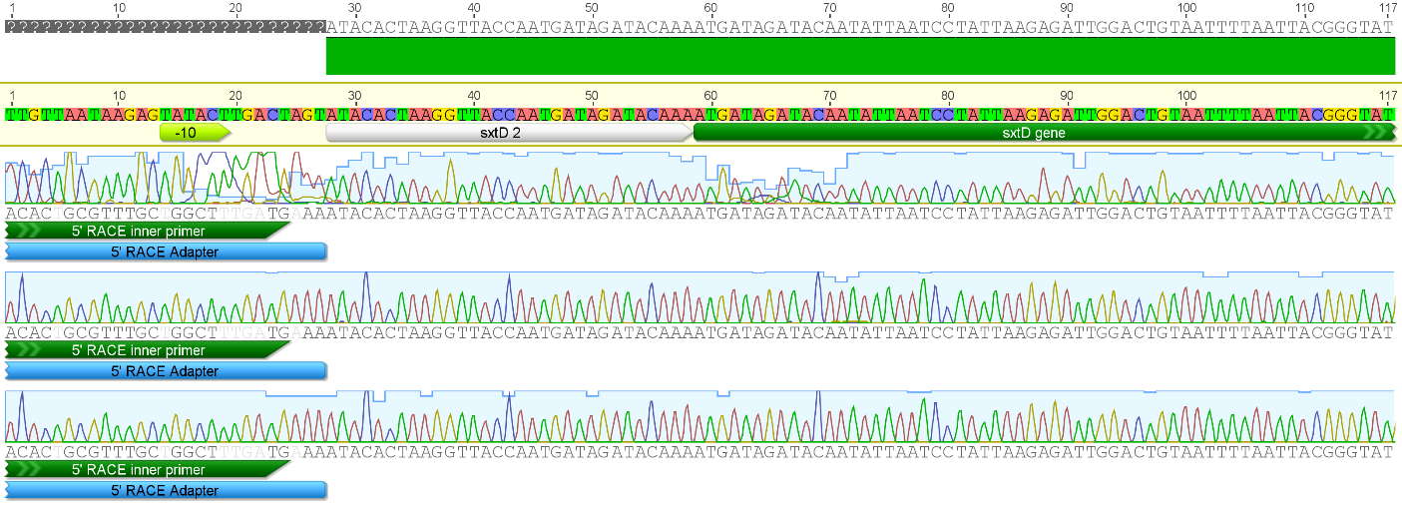
Transcription start point of PsxtD

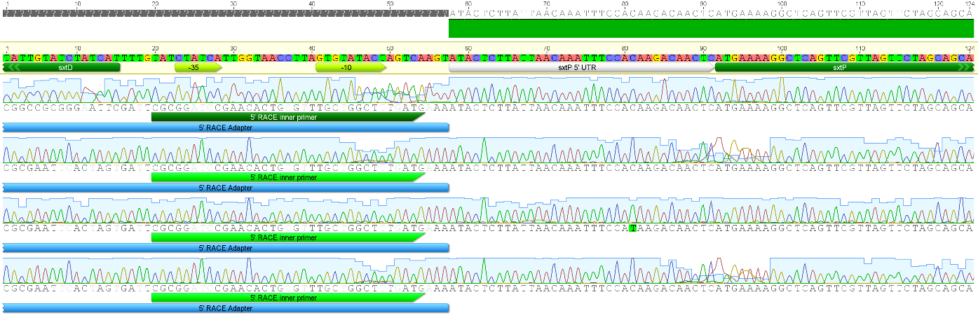
Transcription start point of PsxtP

Transcription start point of PsxtPER2

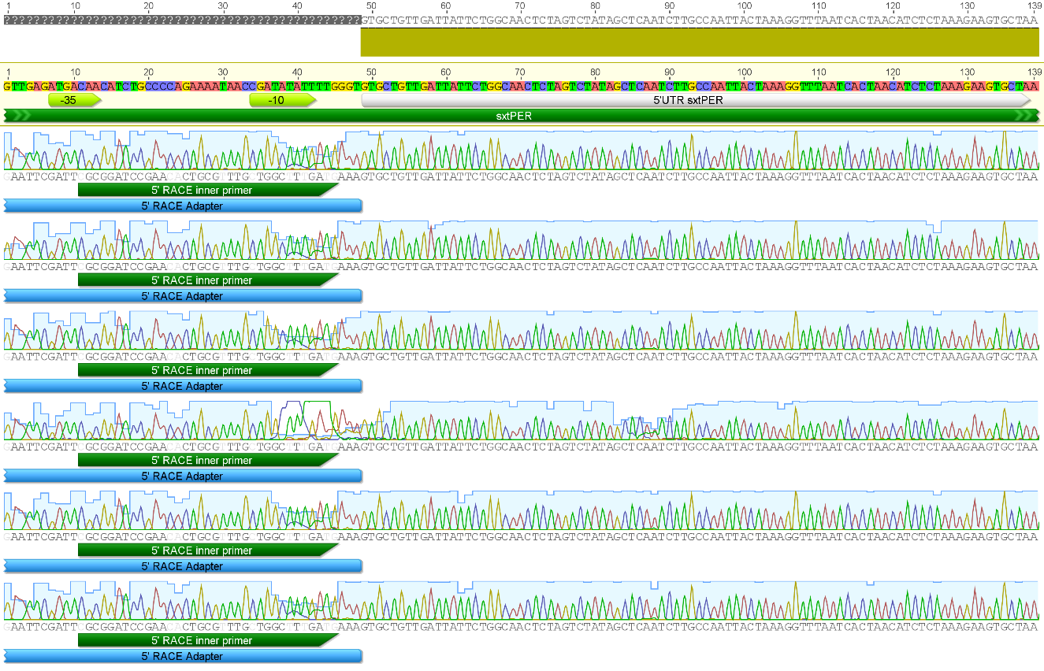

Transcription start point of sxtPER
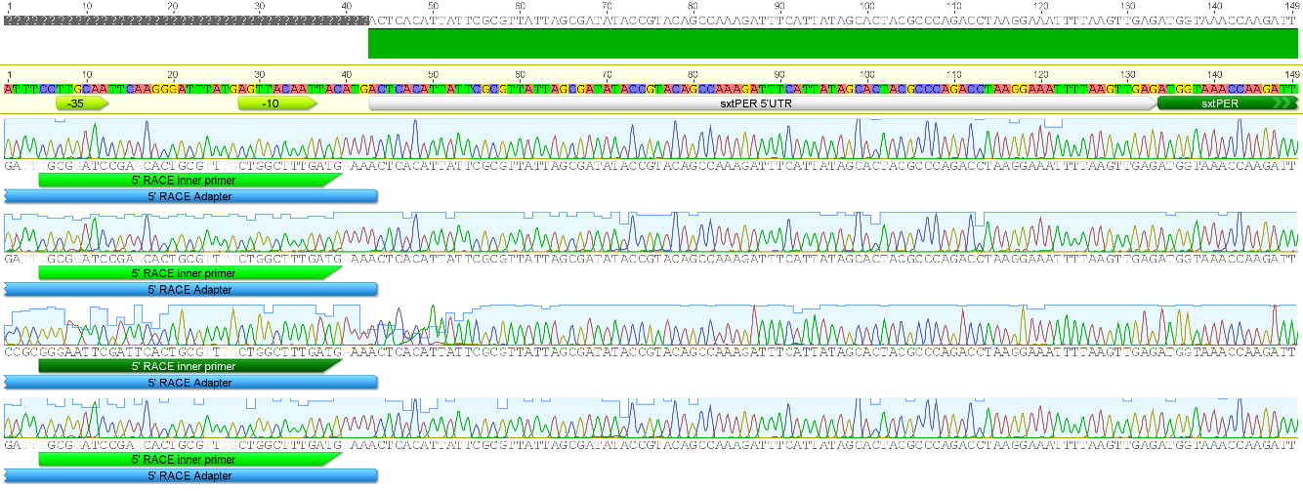

Transcription start point of orf24
